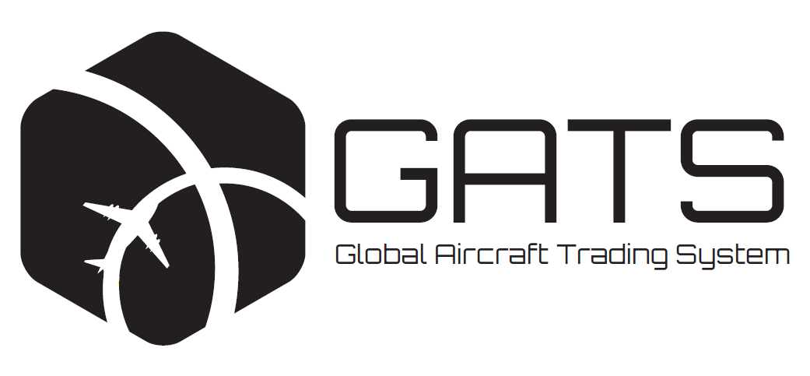
TM
- Modernizes aircraft equipment trading and financing
- Reduces the burdens on and time required by lessees, lessors and financiers of aircraft equipment
- Reinforces the ‘no increased obligations’ lease provision in favour of lessees
- Protects rights of lessees by prohibiting transfers unless agreed conditions in favour of the lessee have been satisfied or waived
- Fully electronic, with e-signatures, e-delivery of documents and use of a secure e-ledger to record transactions
- Voluntary system open to all industry players

FREQUENTLY ASKED QUESTIONS

1. What are the main purposes of GATS?
The trading and financing of aircraft equipment subject to leases is an increasingly important part of the aviation industry. In recent years, as the number of trades has significantly increased, inefficiencies have developed. That has resulted in wasted time and resources for airlines, lessors and financiers alike. The main purposes of the Global Aircraft Trading System (GATS) are to facilitate the trading and financing of aircraft equipment by reducing the burdens on lessees, lessors and financiers and to promote aircraft equipment trading and financing in an efficient, secure and predictable manner which, above all, protects the rights of all parties involved including and especially the lessee's rights under the lease.
GATS will increase the transparency of and confidence in aircraft trading, and further protect rights, by introducing a secure, live and searchable electronic ledger displaying details of ownership of and security interests in GATS trusts.
2. What is the main principle of GATS?
GATS reinforces the principle that a lessee's contractual obligations under a lease agreement may not be increased as a result of aircraft equipment trading.
Through GATS, users are permitted to create, transfer and secure interests in aircraft equipment without disturbing the existing leasing arrangements or having an impact on the contractual rights or protections of the parties to the lease agreement relating to such aircraft equipment.
3. How does GATS work?
GATS builds on the practice of holding aircraft equipment in trusts with bare legal title to the aircraft equipment being held by a professional trustee on behalf of a beneficiary bearing the economic risks and benefits of ownership of the aircraft equipment. This practice is well established and widely adopted for aircraft equipment ownership in the United States. It has been used in Ireland and elsewhere. GATS will expand this practice globally.
One of the principal benefits of holding aircraft equipment in a trust is that the economic and beneficial ownership of that aircraft equipment can be transferred from one party to another without having an impact on the contractual rights, remedies and protections agreed in the relevant lease agreement. The professional trustee is the lessor of record both before and after the transfer so there should be no need to novate or assign the lease agreement as a result of a beneficial interest transfer. If the lease is carefully drafted, the parties can effect any needed technical amendments, for example on the payment accounts and the naming of indemnitees, by notification rather than manual execution.
To further and substantially increase efficiency, GATS features standard forms of transfer documents. They are executed electronically through the GATS platform. These forms, and related Guidance Materials, are being made available by the Aviation Working Group (AWG) in connection with GATS. Parties can agree to eliminate unnecessary practices which have developed over time (such as the need to obtain new IDERAs for the aircraft equipment to reflect changes in ownership and/or security interests).
Details of ownership and security interests created through GATS and the aircraft equipment held in a GATS trust will be recorded in an electronic ledger, using secure technology, searchable by any user of the system. The GATS electronic ledger is updated following each trust creation, transfer and security interest grant.

4. How are the rights of lessees protected by GATS?
The rights of a lessee of aircraft equipment held in a GATS trust are protected in two ways:
First, GATS enables both a transfer of the beneficial interest in a GATS trust and the creation of a security interest in a GATS trust to take effect without changing the contractual provisions of the lease agreement, fully respecting and reinforcing the 'no increased obligations' protections of the lessee. If agreed by the parties, technical amendments can be effected by a notification mechanism, further reducing the time and cost.
Second, any agreed requirements in the lease to be met prior to a transfer of an interest in the aircraft equipment held in a GATS trust can be added to the GATS platform (in an encrypted format visible only to the beneficiary and the lessee unless access has been expressly shared with a third party). These and other ‘advance requirements’ (which can also run in favour of other parties) are fundamental to the GATS’ protective system. The GATS e-system will not permit the beneficial interest in such GATS trust to be transferred (or subjected to a security interest) unless each of the agreed requirements has been marked as satisfied on the system by the lessee (or other beneficiary of the requirement). This strengthens the position of lessees compared to current practice, where a lessee would only have an after-the-fact contract claim in connection with a disputed transfer.
Figure 1 – Confirmation of satisfaction of agreed conditions to transfer
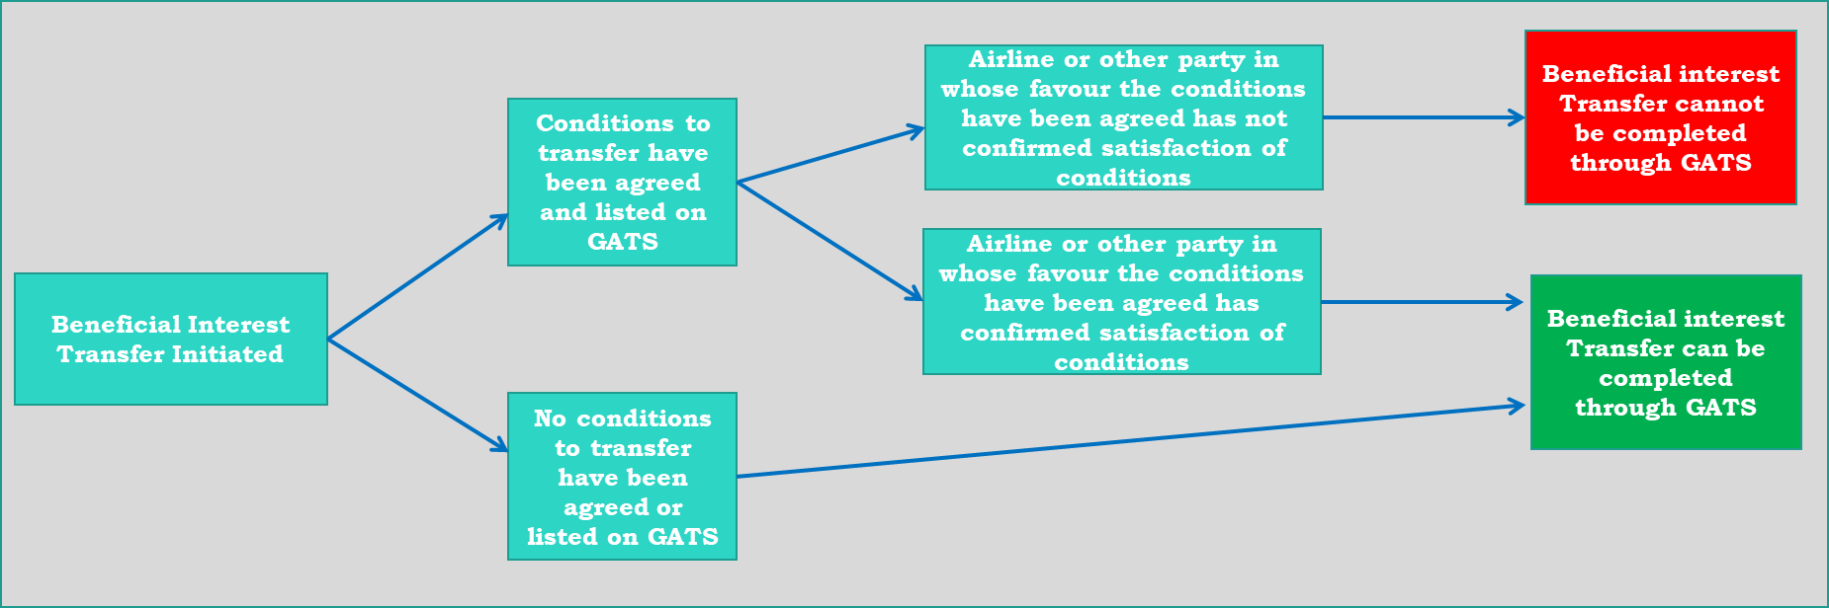
5. Will GATS standardize leasing agreements?
GATS will not standardize leasing documents. The terms of leasing contracts will continue to be negotiated and agreed by lessors and lessees as they see fit.
The Guidance Materials will contain a GATS template transfer clause, for elective inclusion in lease agreements, designed to interlock with and promote the efficient mechanics of GATS transfers. That clause, which can be modified as the parties see fit, builds-in lessee protections, including a no increased obligation clause, and permits advance conditions (advance requirements). The lessee would electronically confirm that such advance requirements have been satisfied or waived prior to the transfer of, or grant of security over, a beneficial interest to a buyer or a financier.
6. Who can participate in GATS and is it voluntary?
There are multiple parties involved when aircraft equipment subject to a lease is traded (for example, the seller, the buyer, the lessee leasing the aircraft equipment, any lender providing financing to the seller prior to the trade and any lender proposing to provide financing to the buyer to make the trade).
Each of these interested parties can use GATS for different purposes. The participants with the most direct involvement in the system are the owners and secured financiers of aircraft equipment. These participants are permitted to use GATS to create, transfer and secure interests in aircraft equipment.
When it decides to enter into a leasing transaction, the lessee will know whether the lessor is a GATS trust (and, therefore, whether the aircraft equipment is held in a GATS trust) because each lessor in GATS must have the words 'GATS Trust' in its name, followed by a unique identification number (for example, GATS Trust 1234).
Lessees leasing aircraft equipment in GATS can also use GATS to ensure that their rights are enshrined in the system and afforded increased protection. GATS will not permit an interest in aircraft equipment to be transferred unless all agreed conditions to transfer (advance requirements) which have been listed on the system (if any) have been confirmed as satisfied or waived by the party with whom such conditions have been agreed. This acts as an electronic safeguard that such agreed requirements are respected. If GATS is utilised for a transaction, but advance requirements in favour of the lessee are not listed on the system, the lessee’s rights with respect to conditions to transfer remain the same as they do in existing practice but without the electronic safeguard that GATS would provide.
Participation in and use of GATS to effect and record transfers is entirely voluntary.
7. How do trusts work?
A trust is an equitable obligation that creates a fiduciary relationship in which one party, the owner trustee, agrees to hold title to assets for the benefit of another party, the beneficiary. The owner trustee is the bare legal owner of the assets on trust for the beneficiary. The beneficiary of a bare trust, such as a GATS trust, ultimately owns and controls the assets of the trust estate.
The key characteristic of a trust is that it allows the legal ownership and the beneficial interest in the assets to be separated: as bare legal owner of the trust property, the trustee contracts with third parties on behalf of, and manages the assets for the benefit of, the beneficiary in accordance with its instructions and the terms of the trust instrument.
Figure 2 – Key characteristic of a trust
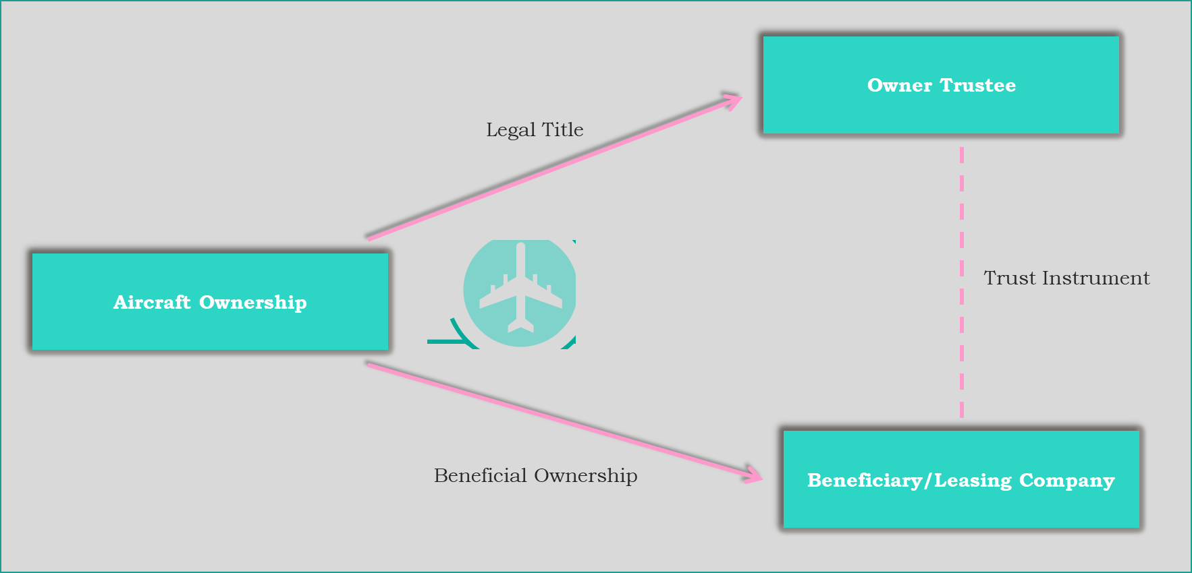
8. What are the eligibility criteria for a trustee to be a GATS trustee?
Any person seeking to act as a GATS trustee of a GATS trust must: (a) be authorised to act as a professional trustee under the laws of the jurisdiction in which such GATS trust is formed (or to be formed); (b) maintain and effectively apply 'know your customer', anti-money laundering and other legal requirements and obligations applicable to regulated banks in such jurisdiction and (c) (unless such entity is regulated as a bank in such jurisdiction) provide AWG with a satisfactory annual verification of such maintenance and effective application from an independent third-party.
9. What happens if a GATS lessor (the trustee) breaches its obligations under a lease?
To the extent that a lessor of aircraft equipment held in a GATS trust breaches any of its obligations under the relevant lease agreement, the lessee would have recourse to the lessor in the usual manner. However, since the professional trust company acting as owner trustee and lessor is the bare legal owner of the aircraft equipment, the lessee may also wish to obtain a separate performance undertaking from the beneficiary of the GATS trust holding the aircraft equipment (or one of its affiliates). In that undertaking, the beneficiary agrees to cause the lessor to meet its agreed obligations under the lease.
As part of the launch of GATS, AWG is publishing two versions of performance undertaking templates which may be used if desired by the transaction parties, with whichever amendments are agreed between the lessor and the lessee. It is intended that an agreed form performance undertaking would be appended as an exhibit to the lease agreement, where agreed between lessor and lessee. Through the execution of this performance undertaking by the trust beneficiary (or the credit party standing behind it), the lessee will have direct recourse to the trust beneficiary (i.e., the real economic owner of the aircraft equipment) or such other party in the event of a breach by the lessor of any of the covered obligations.
Reducing the burden on lessees being one of the primary objectives of GATS, the performance undertaking template does not contemplate the lessee being a party to it but rather a beneficiary of it. While not legally necessary, the parties can change that if they wish.
As a matter of New York and English law, it is not necessary for the beneficiary of such an undertaking (i.e. the lessee in this case) to execute it.
Figure 3– Performance undertaking
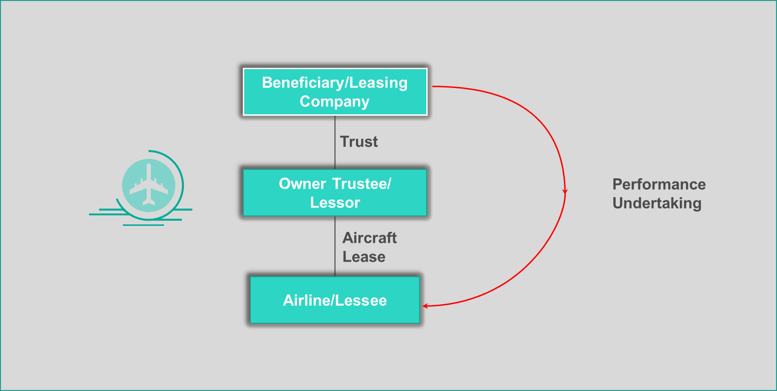
10. How are interests in aircraft equipment transferred through GATS?
After a GATS trust has been created, the beneficiary is entitled to transfer the beneficial interest to another party, subject to the conditions to a transfer set out in the lease. The trust remains intact and the contractual terms of the agreements (including lease documents) entered into by the owner trustee of that trust are unaffected by the beneficial interest transfer.
GATS uses standard forms of transfer documents which are executed electronically by the transferring beneficiary, the new beneficiary and the owner trustee, so that the transfer is completed 100% electronically. The GATS electronic ledger is immediately updated following each transfer to ensure that an accurate, live record of ownership of each piece of aircraft equipment in the system is maintained.
Lessees that wish to have advance conditions to transfer (advance requirements) populated in the GATS system would require such in their lease terms and would utilise the electronic system to confirm the satisfaction (or waiver) of those requirements.
Figure 4 – Transfers through GATS
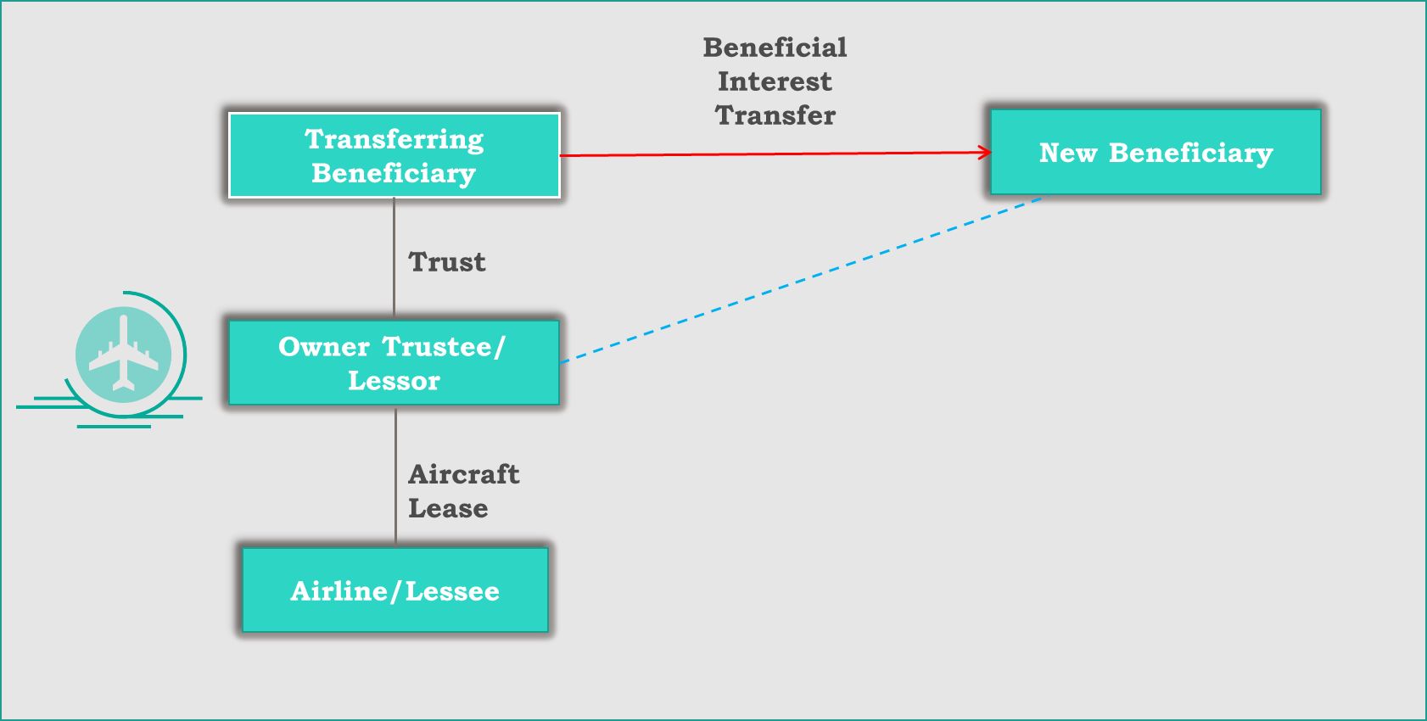
11. What security interest can a beneficiary grant using GATS?
In addition to a standard mortgage over the relevant aircraft equipment and a security assignment of the relevant lease agreement, a secured lender advancing funds against aircraft equipment owned by a GATS trust will also be permitted to take security over the beneficial interest in the GATS trust.
From the perspective of a lessee, any agreed conditions (advance requirement) which must be met in order to grant security over the beneficial interest in the GATS trust can be enshrined on the GATS platform as pre-conditions to the system allowing the grant of the security interest to be completed through GATS.
If the beneficiary defaults on its secured financing, and the secured party is entitled to enforce its security, the secured party will be permitted to transfer the beneficial interest in the GATS trust to itself or to a third party. Any such transfer would be subject to the same terms, conditions and restrictions as are agreed with the lessee in respect of a regular beneficial interest transfer.
Figure 5 – Security Interest Grant
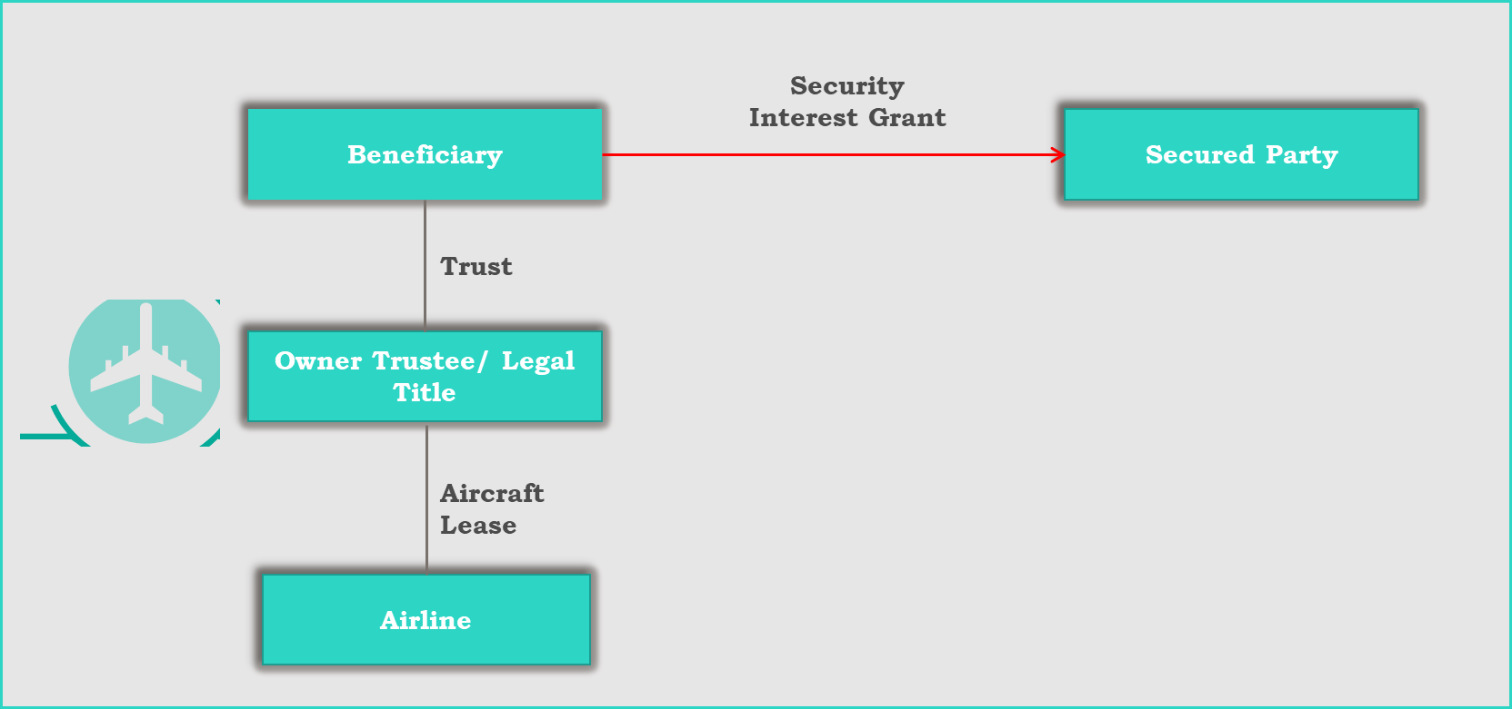
12. Who will act on behalf of GATS Parties on the GATS platform and will there be an electronic escrow to facilitate closing?
The GATS platform requires that each GATS party appoint one or more ‘GATS professionals’ to act on its behalf. At least one of its GATS professionals must be appointed as its ‘administrator’. A GATS professional could be (a) an employee of, or other person in, that GATS party, or (b) any other person outside that GATS party, such as a law firm or other professional advisor. Except for the administrator role, a GATS professional’s authority may be limited in scope, including by limiting what actions it may take, GATS trusts it may work on, transactions it may work on, and/or by time period.
To assist GATS parties and their associated GATS professionals with closings, all transactions effected through the GATS Platform will have the benefit of its electronic escrow facility. The GATS escrow facility will allow parties to one or more transactions that need to be executed in a particular sequence, to (a) preposition electronically executed signatures in escrow, (b) manage satisfaction of the advance requirements for each such transaction and (c) in the case of multiple transactions, enable the execution of such transactions in the desired sequence with zero delay between them. Any GATS professional may initiate the GATS escrow facility environment. Upon all signatures being provided, all advanced requirements being satisfied and each GATS party to the transaction(s) populated in the GATS escrow facility consenting to the release (which will also authorize release of its signature pages), such GATS professional will be authorized to release all signatures from escrow and close all transactions in the GATS escrow facility.

13. What security will reside within GATS and what will exist outside of GATS?
The only security interest which will reside within GATS is a grant of security interest in a GATS trust by the beneficiary. This security interest will be in addition to the other security interests typically taken in secured aircraft financing (including but not limited to a mortgage over the airframe and engines, a security assignment of the relevant lease documents, assignments of warranties, assignments of insurances, account pledges and/or charges over the shares in the beneficiary) each of which will reside outside of GATS and continue to operate in the manner in which they do currently.
14. How is GATS structured?
GATS is structured through the GATS e-terms (being the GATS foundational document). Participation in GATS is governed by a series of bilateral agreements (incorporating the GATS e-terms) each between AWG, acting for the practical application, effectiveness and functioning of GATS and the relevant GATS participant. These agreements are electronic, and are made automatically upon an entity becoming a GATS party.
Accordingly, AWG, in such capacity, is entitled to: (a) secure the intellectual property rights relating to the use of GATS-related trade names, the GATS standard forms, the GATS domain name and content hosted on the GATS platform, (b) enter into a services agreement with a support provider to build, maintain and operate the GATS platform and (c) use any fees generated for the services provided by the GATS platform to pay the support provider, with any excess (noting that AWG is a not-for-profit entity whose purpose is to facilitate aviation leasing and financing) being retained, applied or reinvested to finance, maintain and enhance the GATS platform and to take other action permitted under its constituent documents.
15. Who will build, support and operate the GATS platform?
Aviation Working Group has contracted Fexco to build, support, and operate (including 24/7 support services) the GATS platform. Fexco will be the GATS e-ledger support provider under the GATS e-terms. Fexco is an Irish-based international leader in the development, design and support of platforms for financial transactions, innovative fintech and the provision of technology-based business solutions. The GATS platform will operate using state of the art technology, and is being designed to migrate to a private blockchain if and when AWG concludes that such is advisable.
Information on the GATS platform will be shared with, and advice will be taken from, Aviareto, the registrar of the Cape Town Convention international registry, with a view to advancing best practices on electronic systems and practices for the aviation leasing and financing sector.
16. What will the fee structure be?
No fees, except one to secure a digital signature for transaction signings, will be payable to join GATS.
There will be a fee to execute a GATS transaction and to search the GATS electronic ledger. The GATS e-terms will provide that AWG will set, review and modify such fees, including with a view to funding GATS and the GATS platform.
In addition, and except in the case of transactions involving business aircraft, the GATS e-terms will provide that AWG will set and modify the fees payable by GATS participants to the GATS trustees for acting in such role.
17. When will GATS be available for use?
The GATS platform and electronic ledger is being targeted for use (go-live) by the end of the first quarter of 2020. When operational, fully electronic standard forms of instruments will be executed with digital signatures by those parties wishing to use them.
AWG posted exposure drafts of the GATS documents and Guidance Materials on its website (www.awg.aero) and solicited feedback from the airline industry to answer any queries or address any concerns which lessees had.
For the period commencing on 30 July 2019 and ending on the launch of the GATS platform (the Transition Period), transitional forms of GATS instruments have been made available for download through the AWG website (www.awg.aero) for parties wishing to pre-position aircraft equipment into trusts using GATS-form instruments prior to the launch of the electronic ledger. These instruments allow for manual execution by the parties.
Once the GATS platform goes live, the system will be fully electronic and each trust will be designated a unique identification number (UIN) by the GATS platform which will form part of the name of the trust. In order to avoid a need to change the name of the trust (which could result in filings with an aviation authority or elsewhere), the AWG has reserved a number of UINs for use during the Transition Period which can be retained once the GATS platform launches.
Once the GATS platform launches, parties to a trust formed using the transitional forms of GATS instruments will be permitted to amend and restate such trust using the electronic-form GATS instruments, and, if a UIN has been assigned to that trust by AWG during the Transition Period, to retain that UIN. That will avoid the need for additional filings which a name change would otherwise require.

18. In which jurisdictions will GATS operate?
GATS is a global system with the GATS platform accessible worldwide. Initially, each GATS trust will be formed in one of Ireland, Singapore or the United States (with the laws of such applicable jurisdiction governing the instruments used to create, transfer and grant security interests in such GATS trusts). AWG may expand the list of available jurisdictions over time. This initial trust-jurisdiction limitation does not limit the use of GATS in transactions to airlines worldwide, provided that trusts are recognized in an airline’s jurisdiction. Building on the requirement in the Cape Town Convention to recognize trusts, AWG is working to advance global recognition of trusts in the GATS context. The Guidance Materials will have a summary of trust recognition around the world.
19. What are the tax implications, if any, of using GATS?
A GATS objective is to have the GATS trust treated as a transparent entity (a pass-through) for tax purposes, i.e. for the tax authority to look through the trust to the beneficiary. The standard forms of trust instrument contain features designed to support the treatment of the trust as transparent for tax purposes in Ireland, Singapore or the United States (as appropriate). Tax treatment of a GATS trust will depend on the facts and circumstances of each transaction and the tax legislation in each jurisdiction. AWG will be working to promote this treatment as a global and industry norm.
The Guidance Materials to be posted on the AWG website provide basic points relating to: (a) the beneficiary's entitlement to claim tax depreciation on the consideration incurred for the acquisition of the beneficial interest of an aircraft-owning GATS trust; (b) the applicability of tax treaties to GATS transactions; and (c) the applicability of transfer taxes to transfers of the beneficial interest in a GATS trust. AWG is also assessing item (b) above on a country–by-country basis.
20. What is the relationship between GATS and the Cape Town Convention?
There is no legal relationship between GATS and the Cape Town Convention (CTC), and the two are complementary. CTC, an international treaty, deals with the creation and effects, including in insolvency, of ‘international interests’ in and sales of aircraft and engines (the metal). It contemplates registration with the CTC International Registry relating to transactions within its scope. As described above, GATS does not deal with direct interests in aircraft and engines, as it is based on beneficial interests in trusts over aircraft and engines. As such, no registrations in the CTC International Registry are to be made in connection with transfers of or security over GATS beneficial interests. However, the lease from a GATS trust to an airline, an absolute or security assignment of that lease, or any mortgage over the aircraft or engines as such remain subject to CTC, and, without limitation, should be the subject of CTC registrations.
21. Are there any other uses envisaged for the GATS platform in the future?
GATS contemplates future functionality to facilitate aircraft equipment leasing, trading and financing while protecting the rights of all parties involved. The system is intended to stay cutting edge and forward-looking. The GATS e-terms contemplate expanded functionality to include the electronic exchange and delivery of information and notices; the electronic granting of consents; and the electronic execution of other agreements frequently used in the aviation leasing and financing industry. In due course, AWG will consider additional functionality for the platform. They might include, for example, use of GATS regarding consents in sub-leasing transactions or in connection with the trading of fractionalized or sub-interests in beneficial interests, provided there is no adverse effect on GATS transactions, the underlying lease, or the parties’ rights under either.
The use of any such expanded functionality would be entirely optional.
22. Where can I find additional information on GATS?
AWG has posted all GATS documentation and Guidance Materials to its website along with GATS Transition Period instructions relating to the use of the transitional forms of GATS instruments.
The Guidance Materials will be updated from time to time and each update will be posted on the AWG website, and, from the go-live date, on the GATS platform.

